**INVENTION MANAGEMENT SYSTEM** GROUP – 10

**PHASE – 3 – NORMALIZATION**

**NORMALIZATION**

* Normalization is a database design technique that reduces data redundancy and eliminates undesirable characteristics like Insertion, Update and Deletion Anomalies.
* Normalization rules divides larger tables into smaller tables and links them using relationships.
* The purpose of Normalization in SQL is to eliminate redundant (repetitive) data and ensure data is stored logically.
* The most commonly used normal forms are
  + - First normal form(1NF)
    - Second normal form(2NF)
    - Third normal form(3NF)
    - Boyce & Codd normal form (BCNF)

**FIRST NORMAL FORM (1NF)**

* In first normal form, an attribute (column) of a table cannot hold multiple values.
* It should hold only atomic values.
* Each record needs to be unique.

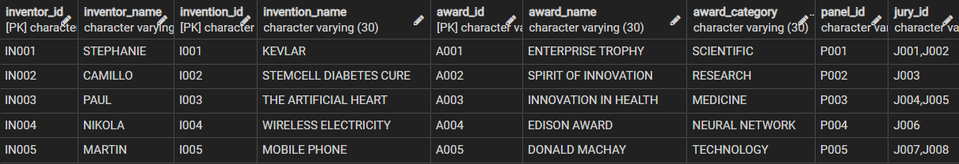

* This relation is not in 1 NF because the attribute **Jury_Id** contains multiple values.
* So, in order to make it 1 NF we have to create new tuples for all multiple values so that each tuple will have only one value.

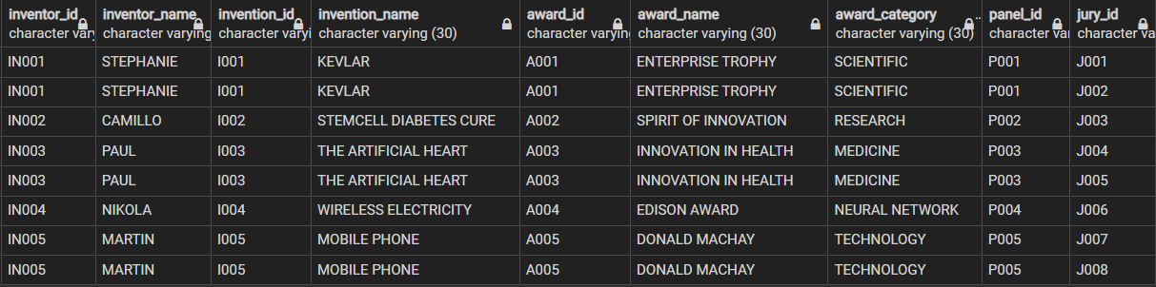

* Now this relation is in 1 NF.

**SECOND NORMAL FORM (2NF)**

* A table is said to be in 2NF if both the following conditions hold:
  + Table is in 1NF (First normal form)
  + There should not be any partial dependency.
* **Partial Dependency** occurs when a non-prime attribute is functionally dependent on part of a candidate key.
* All the non-primary key columns in the table should depend on the entire primary key.
* **No partial dependency of primary key**is allowed but a non-prime attribute can depend on non-prime attribute
* An attribute that is not part of any candidate key is known as non-prime attribute.



* Here the functional dependencies are,
  + - INVENTOR_ID --> INVENTOR_NAME
    - INVENTION_ID --> INVENTION_NAME
    - AWARD_ID --> AWARD_NAME
    - AWARD_ID --> AWARD_CATEGORY
    - JURY_ID --> PANEL_ID
    - PANEL_ID --> AWARD_ID
* The FD **[INVENTOR_ID --> INVENTOR_NAME]** is a partial dependency.
* Non-prime attribute shouldn’t dependent on the subset of the candidate key.
* So, we have to create separate tables for sets of values that apply to multiple records and relate these tables with a foreign key.
* This relation has a composite primary key,
  + - Invention_Id
    - Inventor_Id
    - Award_Id
    - Jury_Id
* The non-prime attributes are,
  + - Invention_Name
    - Inventor_Name
    - Award_name
    - Award_category
    - Panel_Id

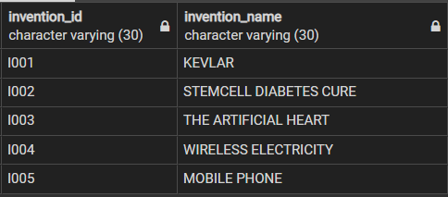

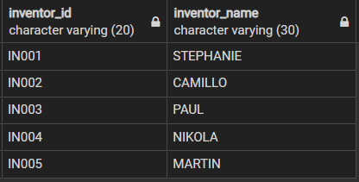

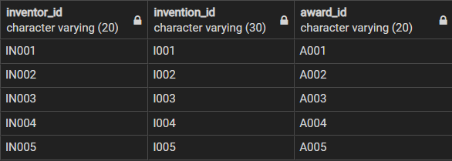

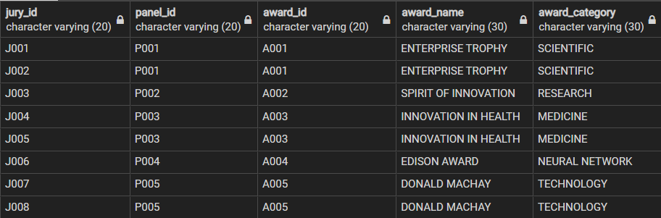

* Now after creating separate tables for sets of values that apply to multiple records and relating these tables with a foreign key the table is now in 2 NF.

**THIRD NORMAL FORM (3NF)**

* The relation is said to be in 3 NF if it follows two rules.
  + - The table must be in 2NF.
    - No non-prime attribute must define another non-prime attribute.
* A Transitive Functional Dependency is when a non-key column is Functionally Dependent on another non-key column, which is Functionally Dependent on the Primary Key.



* In this relation, Award_Id 🡪 Jury_Id and Jury_Id 🡪 Panel_Id which in turn signifies that Award_Id 🡪 Panel_Id.
* So, this relation is not in 3 NF.
* In order to make it in 3 NF, we have to split this relation into two where the first relation have the attributes Panel_Id 🡪 Award_Id, Award_Name, Award_Category and second relation have the attributes Jury_Id 🡪 Panel_Id.

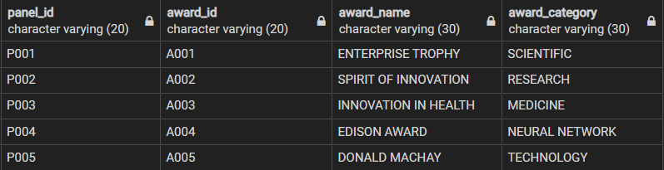

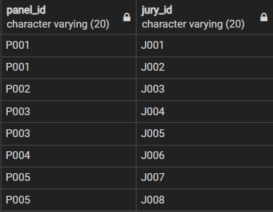







* Now the relation is in 3 NF.

**BOYCE CODD NORMAL FORM (BCNF)**

* Boyce and Codd Normal Form is a higher version of the Third Normal form which deals with certain type of anomaly that is not handled by 3NF.
* A 3NF table which does not have multiple overlapping candidate keys is said to be in BCNF.
* For a table to be in BCNF, following conditions must be satisfied:
  + - R must be in 3rd Normal Form
    - For each functional dependency (X -> Y), X should be a super Key.
* This relation is already in BCNF.

**THANKYOU !!**

**GROUP 10**

* RAHAN MANOJ – AM.EN.U4CSE19144
* S ABHISHEK – AM.EN.U4CSE19147
* HARSHA SATHISH – AM.EN.U4CSE19123
* ARVIND KUMAR K – AM.EN.U4CSE19109